**FUND TRANSFER APPLICATION**

**Project Overview:**

Fund Transfer Application is a console based application .This System provides separate for Admin and User. In admin, the basic operations for fund transferring like adding the account, updating the account, deleting the account and viewing the account and admin can monitor the whole process. Once a user logs in with their credentials they can view their particular records and also they can transfer amount from one to another. It is important financial activities will be carried out by any person.

**SCOPE OF PROJECT:**

**In Scope:**

Following are the key features that needs to be implemented for Admin and User:

**Admin:**

1. Login
2. Add Account
3. View Account
4. Update Account
5. Delete Account
6. View User
7. Delete User

**User:**

1. Login
2. View User
3. Transfer Amount

**DBSHEMA:**

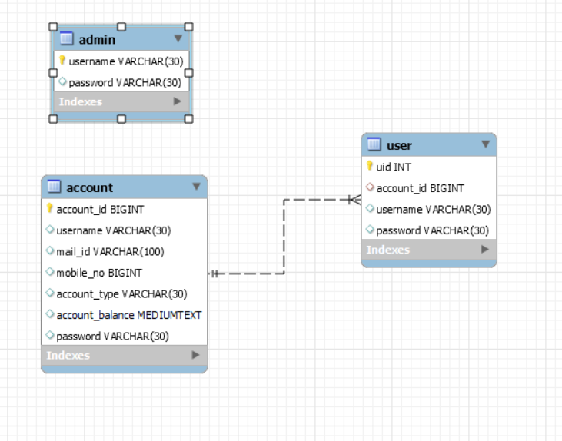

**USE CASES:**

There will be **two types of users** whom will be using this application

1. Admin
2. User

**Key Responsibilities:**

* Admin - Responsible for managing the account details in Fund transfer application.
* User - Users can view the account and transfer the amount.

**ADMIN SCOPE:**

**Admin:**

1. Admin should login with their credentials.
2. Admin page has menu of options.

**Admin Login:**

The admin can login by providing the following user credentials.

1. Username
2. Password

**Admin Add Account:**

The admin can add the account details into the fund transfer application.

**Admin View Account:**

List of account details shown to the admin with following details.

1. Account id
2. Username
3. Mail id
4. Mobile Number
5. Account Type
6. Account Balance
7. Password

**Admin Update Account:**

According to their requirements admin can update the account details.

**Admin Delete Account:**

Using **foreign key**, User table can be deleted first after that based on account id the admin can delete the account details into the fund transfer application which acts a parent table.

**Admin View User:**

Admin can view the details of user. List of user details shown to the admin with following details.

1. User id
2. Account id
3. Username
4. Password

**Admin Delete User:**

Based on account id the admin can delete the account detail of user. User table acts as a child table.

**USER SCOPE:**

**User**

1. User should Login with their credentials.
2. User page has menu of options.

**User Login:**

The user can login by providing the following user credentials.

1. Username
2. Password

**User View Account Details:**

Account details shown to the user with following details.

1. Account id
2. Username
3. Mail id
4. Mobile Number
5. Account Type
6. Account Balance
7. Password

**Transfer Amount:**

User can transfer the amount from one account to another account.